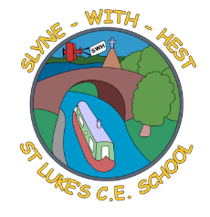
Slyne-with-Hest St Luke’s C.E. Primary School
EYFS Curriculum Information
Summer Term 2 2026
English  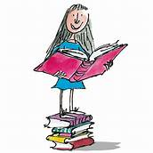 | In phonics we will work on the next phase – no new sounds to learn, but reinforcement of what we have already covered, as well as learning to read consonant clusters.  The children will be expected to become more fluent readers, with less ‘sounding out’ now and more reading of whole words and sentences.  They will be expected to write increasingly long phrases and sentences for themselves, sometimes using full stops and capital letters.
Maths  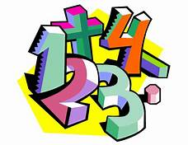 | In Maths we aim to deepen the children’s understanding of the work we have carried out during this year. The children will be expected to know some number pairs within 10 including halves & doubles.  We will re-visit adding, taking away and sharing, as well as working on patterns and spatial understanding including enjoying working with simple maps.
Topics   | This half term our topic is ‘All About Books’.  We will have fun with books about maps, Monsters, ‘Harry’s Home’, ‘Dear Zoo’, ‘The Very Hungry Caterpillar’ with books about Teddy Bears to finish off.
R.E. | Our RE work is based on the Blackburn Diocesan scheme.  Our topic for this half term is ‘Special Places’.
Home School Partnership  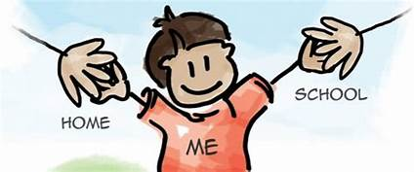 | We would like you to help your child at home with the following activities:  - Hearing their home reader at least once a day – more if you can!  - Supporting with learning and re-visiting letter sounds / spellings / high frequency words  - Having fun learning number pairs as well as halves and doubles.
Reminders | This half term PE will be on Wednesdays and Fridays.  Children should come to school in their PE kit on this day so they don’t need to get changed.

