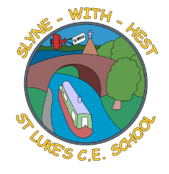
Slyne-with-Hest St Luke’s C.E. Primary School
EYFS Curriculum Information
Summer Term 1 2026
English  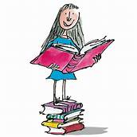 | We will continue to develop the children’s speaking skills, expecting them to converse properly with us and to speak in sentences.  In phonics we will continue to learn and put into use the digraphs and tricky words for Reception children.  The children will be expected to become more fluent readers, with less ‘sounding out’.  They will be expected to write phrases and sentences for themselves, with a focus on controlling the size of letters.
Maths  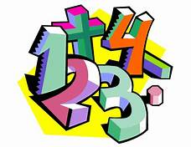 | In Maths we will continue to learn and remember number bonds to 5, some to 10 and halves and doubles to 10.  We will look at the pattern of numbers when we count past 20.  We will start to group and share numbers.
Topics   | This half term our topic is ‘The Senses’. We will explore one each week, along with learning about St George (the patron saint of England) in the second week.  For the last week of term we will have our own ‘Science’ week.
R.E. | Our RE work is based on the Blackburn Diocesan scheme.  We will be looking at New Testament stories, undertaking a unit of work called ‘Stories Jesus Told’ before celebrating Pentecost in the last week of the half term.
Home School Partnership  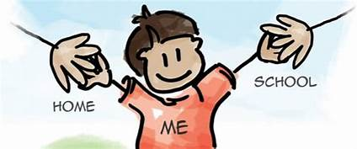 | We would like you to help your child at home with the following activities:  - Hearing their home reader at least once a day – more if you can!  - Completing each phonics homework as it comes home, as well as working on the previous sounds covered.  - Supporting with learning weekly spellings, as well as looking back at previous spellings to consolidate them.
Reminders | This half term PE will be on Wednesdays and Fridays.  Children should come to school in their PE kit on this day so they don’t need to get changed.

