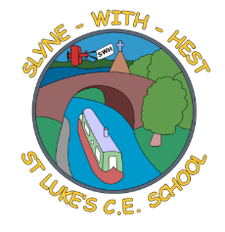
Slyne-with-Hest St Luke’s C.E. Primary School
Year 2Curriculum Information
Spring Term 2 2026
English   | We will be looking at books by Allan Ahlberg and thinking about ‘significant authors. We will be focussing on Burglar Bill And also looking at Cops and Robbers and Happy Families stories. We will be working towards writing ‘What am I? Riddles and a narrative piece of writing linked to the text. We will continue to work on weekly spellings in class and with our focus on handwriting and correct posture/ letter formation.
Maths  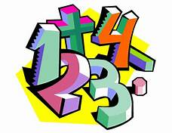 | In Maths over the next few weeks, we will be working on Multiplication and division, money, addition and subtraction, length and 2D and 3D shape.  We will be developing the use of Daily Ten at the start of each maths lesson to develop the confidence to answer quick fire mental maths questions. (This can be accessed at home - link on class page of the website)
Science   | This half term we will be learning about Animals including Humans.
Theme (History / Geography/ Art and DT)   | The main class theme this half term is based on Nurturing Nurses  In History, we will be considering nurses who made significant improvements to nursing. Florence Nightingale, Mary Seacole and Edith Cavell.  In Design and Technology we will designing and making healthy wraps. We will be tasting different ingredients and thinking about which to include in our final design and make. We will taste and evaluate our wraps! We will also be looking at food groups and healthy foods (linked with Science)  In Music, we will be working hard to learn songs linked to A day at the seaside in preparation for our permormance at the Music Festival.
R.E. | This half term our unit of work is from the Blackburn Diocesan scheme.  How do symbols help people to understand the Easter Story?
Home School Partnership   | We would like you to help your child at home with the following activities:  - Reading at least three times in a week – more if you can!  - Completing weekly Maths homework which will be given on a Wednesday to be handed in the following Monday  - Supporting with learning spellings / high frequency words through regular ptactice / activities on Ed shed.  - Count in 2s, 5s and 10s, learn these times tables and answer related mukltiplication and division questions.
Reminders | This half term PE will be on a Tuesday and Wednesday  Children should come to school in their PE kit on this day so they don’t need to get changed.

