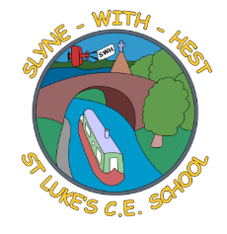
Slyne-with-Hest St Luke’s C.E. Primary School
Year 5 Curriculum Information
Spring Term 2 2026
English  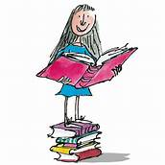 | This half term in English we are continuing to use the novel ‘The Explorer’ by Katherine Rundell as the basis for our work. We will be writing our own adventure stories based on the novel. Then we will have a narrative poetry focus on ‘The Alchemist’s Letter’. We will continue to focus on developing our reading comprehension skills and we are focusing time adverbials and using dialogue to advance action in our SPAG sessions.
Maths   | This half term in maths we will be developing our mental and written strategies for division. We will be looking at area, volume, 2D and 3D shapes. We will be developing our understanding of how to calculate fractions. We will also focus on interpreting tables and graphs in statistics.  We will also be continuing with our weekly arithmetic work focusing on all 4 rules of arithmetic, fractions and decimals.
Science   | This half term our main theme is ‘Forces’. Children will explore how forces affect the movement of objects. They will learn about gravity, friction, air resistance and water resistance and investigate how mechanisms such as levers, pulleys and gears help us to move or lift objects more easily. Through practical investigations, they will develop their scientific enquiry skills and deepen their understanding of how forces work in the world around them.
Theme (History / Geography/ Art and DT)   | The main class theme this half term is based on Rainforests. In Geography we will continue to focus on the Amazon rainforest and look at climate and life in the rainforest in more detail. In DT, we will be making a pop-up book based on nursey rhymes.  In Music we will be continuing our compositional unit based around the main rainforest theme and we will continue to learn the songs for the music festival.
R.E. | This half term our unit of work (based on the Blackburn Diocesan scheme) is  Easter : Why do Christians believe that Easter is a celebration of Victory? This unit will develop the children’s beliefs and understanding of how Christ’s victory over death is a great triumph and part of God’s rescue plan for his people. We will look in more depth at why Easter is such a great celebration in the Christian calendar.
Home School Partnership   | We would like you to help your child at home with the following activities:  - Reading at least three times in a week – more if you can!  - Completing weekly English and Maths homework – Maths will be set on a Friday and English on a Monday.  - Supporting with learning spellings / high frequency words. Our spelling test will be on a Monday.
Reminders | This half term PE will be on a Tuesday.  Children should come to school in their PE kit on these days so they don’t need to get changed.  We will be going swimming on a Friday.

