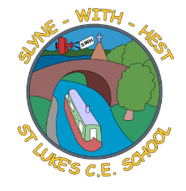
Slyne-with-Hest St Luke’s C.E. Primary School
Year 3 Class Curriculum Information
Spring Term 2 2026

English  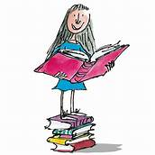 | In English, we will be reading and studying The Iron Man. This is always a popular story with the children as it allows them to explore sci-fi characters and events. We will begin by using lots of different reading skills and writing in role. The children will create a new character for their own version of the story based on the first two chapters. We will be continuing to look at a range of conjunctions and how to use and punctuate direct speech in our own narrative writing.
Maths  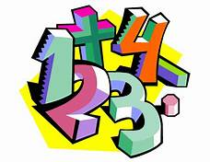 | In Maths, we will start by looking at 2D shapes and looking at angles within shapes. We will be hunting for right angles and deciding if an angle is bigger or smaller than a right angle. We will also be introducing new vocabulary linked to shapes; parallel and perpendicular lines. Following our work on shape, we will recap our written methods for addition and subtraction before using our skills when analysing and recording data.
Science   | During the Spring term we will be learning about rocks and soils. We will begin by discussing what a rock is and what they can be used for. We will learn about the different types of rock and test and compare them. We will also look at fossils, exploring how they are formed and what they can tell us about the past. We will then move onto soil to find out what it is made from.
Theme (History / Geography/ Art and DT)   |   This half term we study the geography unit Volcanoes and Earthquakes. The children will investigate earthquakes and volcanoes: what they are; why they happen and how they affect the landscape and human activity.  In DT we will be looking at, designing and creating a  moving model using pneumatic power.
R.E. | This half term we will be focusing on the Easter story. We will be exploring the different feelings experienced at different points of the Easter story and look at whether the cross is a symbol of sadness or joy.
Home School Partnership   | We would like you to help your child at home with the following activities:  - Reading at least three times in a week – more if you can!  - Completing English and Maths homework  - Supporting with learning spellings / high frequency words and times tables. Please encourage your child to log in to spelling shed and TT rockstars several times a week. Just a few minutes at a time really does make a difference.
Reminders | This half term PE will be on Mondays and Thursdays.  Children should come to school in their PE kit on these days, so they don’t need to get changed.

