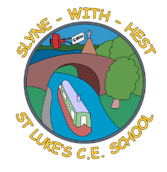
Slyne-with-Hest St Luke’s C.E. Primary School
EYFS Curriculum Information
Spring Term 2 2026
English  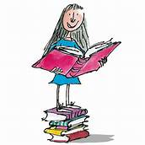 | We will continue to develop the children’s speaking skills, expecting them to converse properly with us and to speak in sentences.  In phonics we will continue to learn the sounds and digraphs for Reception children. This half term’s sounds are igh – oa – oo – ar – or – ur – ow.  The children will continue on their journeys to read and write simple sentences for themselves.
Maths  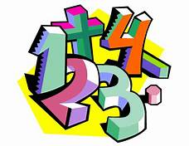 | In Maths we will be firming up the children’s understanding of numbers to 10, including being able to remember some number bonds.  We will explore length, height and time.  We will also learn about 3D shapes and re-visit our earlier work on patterns.
Topics   | This half term our weekly topics are quite different from each other and don’t have an umbrella title. They are:  - The Sun (finishing our weather topic)  - St David (the second of our Patron Saints)  - History Week  - New Life  - St Patrick  - Easter
R.E. | Our RE work is based on the Blackburn Diocesan scheme.  We will continue to work on Stories Jesus Heard (Old Testament stories), and then we will move onto learning about Easter.
Home School Partnership  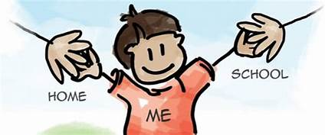 | We would like you to help your child at home with the following activities:  - Hearing their home reader at least once a day – more if you can!  - Completing each weekly phonics and handwriting homework, as well as working on the previous letters covered.  - Supporting with learning letter sounds / spellings / high frequency words.  - Helping to reinforce those good writing habits with regard to pencil grip and letter formation.
Reminders | This half term PE will be on Wednesdays and Fridays.  Children should come to school in their PE kit on these days so they don’t need to get changed.

