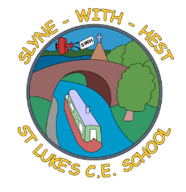
Slyne-with-Hest St Luke’s C.E. Primary School
Year 5 Beech Curriculum Information
Autumn Term 2 2025
English  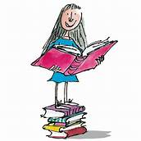 | This half term in English we will be basing our English work on our Victorians topic. We will be looking at the story ‘Oliver Twist’ by Charles Dickens and we will be writing our own chapter. Then we will look at playscripts linked to the text.  We will focus on relative clauses and verb tenses during our SPAG sessions and develop our reading skills through focused comprehension sessions.
Maths  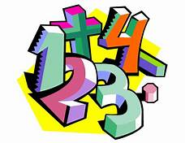 | This half term in maths will be focusing on multiplication and division. We will be developing both aspects further through word problems.  We will be looking at problems involving area and time. Our weekly arithmetic work will involve problems with all 4 rules of arithmetic, fractions, percentage and decimals.
Science   | Our new topic will be Properties of Materials. We will be looking at key language to describe the different properties of materials and considering how their properties make some materials particularly useful for certain jobs. We will investigate the properties of solids, liquids and gases, and processes which involve reversible and irreversible changes.
Theme (History / Geography/ Art and DT / Music)   | Our topic this half term is The Victorians. We will be learning about Queen Victoria and the impact of the industrial revolution. We will look at some of the key inventions during this time and investigate what medical care was like. We will also make comparisons between the lives of rich and poor people. This half term, we will be designing and making soft toys in our DT unit.  In Music we will be developing singing skills as we prepare for the KS2 Christmas concert.
R.E. | We will begin our Christmas unit and focus on the story of the Nativity. We will compare the gospel versions of the story and analyse them on a deeper level, making links to the Bible as a whole and God’s great plan. We shall be reflecting on how our own celebrations reflect the true meaning of Christmas as the unit unfolds.
Home School Partnership   | We would like you to help your child at home with the following activities:  - Reading at least three times in a week – more if you can!  - Completing weekly English and Maths homework – English will be set on a Monday and Maths on a Friday.  - Supporting children to access spelling shed at home. Our spelling test will be on a Friday.
Reminders | This half term PE will be on a Tuesday and a Friday. Children should come to school in their PE kit on this day so they don’t need to get changed.

