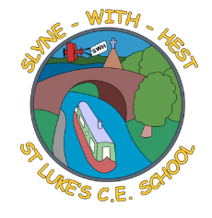
Slyne-with-Hest St Luke’s C.E. Primary School
Year 3 Class Curriculum Information
Spring Term 1 2026

English  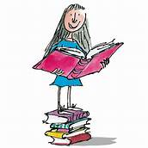 | This half term our English work will be linked to our work on The Stone Age. We will start by looking at instructional texts and identify the features of them whilst learning ‘How to wash a Woolly Mammoth!’ We will then move onto a narrative unit all about ‘The Stone Age Boy’. We will read and discuss the story and then use it to help us plan and write our own stone age stories.
Maths  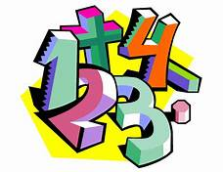 | In Maths we will start by looking at place value, addition and subtraction. We will then move onto multiplication and division, including using more formal methods. We will also begin looking at fractions for the first time this year. The children are expected to be able to identify a fraction and place on a number line. They also need to know vocabulary associated with fractions including numerator, denominator, equal parts and the different fractions (half, thirds, quarters etc)  As ever, there is a huge focus on knowing times tables facts for the 2, 5 and 10 times tables. We are looking at the 3s, 4s and 8s alongside these also.
Science   | Throughout this half term we will be looking at Forces and Magnets. We will be exploring pushes and pulls and comparing how some things move on different surfaces. We will investigate what materials and objects are magnetic and look at different types of magnets.
Theme (History / Geography/ Art and DT)   | Our theme this half term is Stone Age to Iron Age. We learn what life was like for the Stone Age people, what they ate and about some famous places such as Skara Brae and Stonehenge. We will use a range of sources to see what historians have found out about life in the Stone Age.  In art, we will be exploring charcoal drawings linked to cave art.
R.E. | This half term we will be investigating Jesus and the way he changed/changes people’s lives. We will be looking at various stories in the Bible and finding out about the people who met Jesus and were changed by him. We will then look at how Jesus changes the lives of Christians today.
Home School Partnership  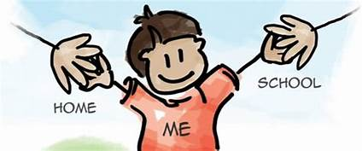 | We would like you to help your child at home with the following activities:  - Reading at least four times in a week – more if you can!  - Completing weekly English and Maths homework.  - Supporting with learning spellings / high frequency words. The children will bring a spelling list home on a Monday and will be tested the following Monday. We will look at these words throughout the week in school but they also need to complete their Look, Say, Cover, Write, Check pages at home.  They should also be logging on to Spelling Shed a couple of times a week.  - Learning their times tables. In Year 3 we focus on x3, x4, x8 in addition to x2, x5 x10 learned in Year 2. The children will be given a TT Rockstars login to practise at home.
Reminders | This half term PE will be on MONDAYs and THURSDAYs.  Children should come to school in their PE kit on these days, so they don’t need to get changed.

