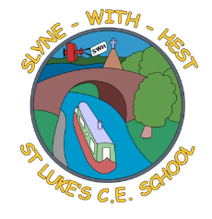
Slyne-with-Hest St Luke’s C.E. Primary School
EYFS Curriculum Information
Spring Term 1 2026
English  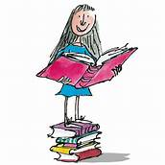 | We will continue to develop the children’s speaking skills, expecting them to converse properly with us and to speak in sentences.  In phonics we will continue to learn the sounds and digraphs for Reception children – this half term we will cover j – v – w – x – y – z – zz – qu – ch – sh – th – ng – ai – ee.  The children will continue on their journeys to read and write simple sentences for themselves.
Maths  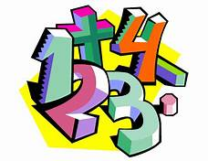 | In Maths we will consolidate our work from the autumn term, comparing, ordering and exploring numbers. We will continue to explore the composition of numbers, learning number pairs and developing number sentences. We will explore length, height and time.
Topics   | This half term our main topic is ‘All About Weather and Season’. We start off with ice and cold, looking at winter and the changes in the world around us. We will also cover ‘Rain’ and ‘Wind’ before half term. We will celebrate Chinese New Year and the final week of the half term will be a ‘health’ week, to coincide with the visit from Life Education and Harold the Giraffe.
R.E. | Our RE work is based on the Blackburn Diocesan scheme.  We start off with ‘My World & Jesus’ World, before exploring some of the Old Testament stories.
Home School Partnership  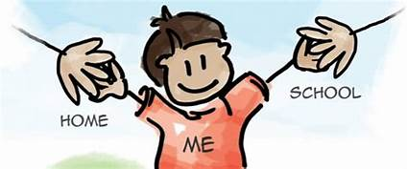 | We would like you to help your child at home with the following activities:  - Helping to learn the weekly poem (as sent home and on the school webpage).  - Hearing their home reader at least once a day – more if you can!  - Supporting with learning spellings each week.  - Helping with extra phonics and handwriting which we will build in this term, to consolidate what we have done in school.
Reminders | This half term PE will be on Wednesdays and Fridays.  Children should come to school in their PE kit on these days so they don’t need to get changed.

