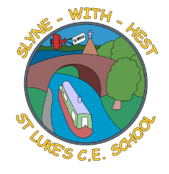
Slyne-with-Hest St Luke’s C.E. Primary School
Year 3 Class Curriculum Information
Autumn Term 2 2025

English  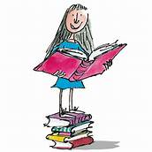 | This half term, we will start by looking at poetry before beginning our study on a range of Aesop’s Fables. We will look at the structure and morals in the fables and then have a go at writing our own. The children will also look at some Grammar techniques they can use in their writing. For example, determiners ‘a’ and ‘an’, conjunctions and inverted commas for speech.  Spelling homework will continue to be set on a Monday to be completed by the following Monday.
Maths  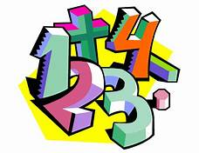 | In Maths, we will starting our work on multiplication and division. This will include more work on their 3 and 4 times tables. Children are encouraged to practise their 2x, 5x, 10x and now their 3x at home regularly. We will be using the grid method for written multiplication and looking at how we can work out doubles and halves. We will complete the half term with work on Time and 3D Shapes.  Maths homework will continue to be set on a Tuesday to be completed by the following Monday.
Science   | Throughout this half term we will be looking at Forces and Magnets. We will be exploring pushes and pulls and comparing how some things move on different surfaces. We will investigate what materials and objects are magnetic and look at different types of magnets.
Theme (History / Geography/ Art and DT)  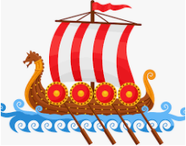 | We will continue to focus on history and taking a trip down the Nile where we will find out all about Ancient Egypt. The children will study Ancient Egyptian Gods, Pharaohs, the art of mummification and why the pyramids were built.  We will cover some elements of Geography, looking at where Egypt is, what the country is like now and the importance of the River Nile.  In DT we will be designing and making an Egyptian collar, using our cutting and sewing skills.
  R.E. | In RE we are continuing our unit, ‘Is the Golden Rule agreed by everyone. We will continue our quest looking at the beliefs of people who follow Sikhism and compare their rules with Christianity and Islam. In December, we will start our Christmas unit: How does the presence of Jesus impact people’s lives?
Home School Partnership  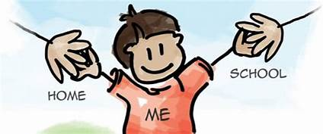 | Please help your child home with the following activities:  - Reading at least four times in a week – more if you can!  - Completing weekly English and Maths homework.  - Supporting with learning spellings / high frequency words. The children will bring a spelling list home on a Monday and will be tested the following Monday. We will look at these words throughout the week in school but they also need to complete their Look, Say, Cover, Write, Check pages at home.  - Learning their times tables. In Year 3 we focus on x3, x4, x8 in addition to x2, x5 x10 learned in Year 2. The children will be given a TT Rockstars login to practise at home.
Reminders | This half term PE will be on a MONDAY and a THURSDAY. Children should come to school in their PE kit on these days.  Please ensure your child brings a water bottle every day.

