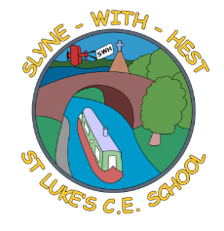
Slyne-with-Hest St Luke’s C.E. Primary School
EYFS Curriculum Information
Autumn Term 2 2025
English  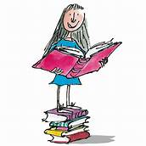 | We will build on the successes of last term, helping the children to develop good speaking, listening and conversation skills.  We will continue to have a daily phonics lesson, where the children are taught the early stages of reading and writing. As soon as each child is ready they will also start on our school reading scheme books, which they will bring home each evening.  There will be a poem for the children to learn each week; these are found on our class page of the school website as well as coming home in their bags.  Remember we have a class library.
Maths   | In Maths we will explore 2D shapes and spatial awareness.  We will develop an in-depth knowledge of numbers to 5.  We will learn about more and less.  We will continue to develop pattern making skills, as well as helping the children to make up and play simple games.
Topics   | Our main topic for this half term is ‘People Who Help Us’, although we will also explore Bonfire Night, St Andrew and of course Christmas.  We look at Postal Workers, Police Officers and Firefighters, touching on other emergency services too. There will be plenty of opportunities for art, role play and discussions as we go through the term.
R.E. | Our RE work is based on the Blackburn Diocesan scheme.  We will enjoy learning about ‘Special People’, before beginning the very large topic of Christmas.
Home School Partnership  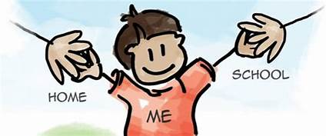 | We would like you to help your child at home with the following activities:  - Hear them read their school readers (when they start on them), at least twice a book initially.  - Helping them with early phonics so that they can access our reading scheme.  - Complete and then continue to work on handwriting activities which are sent home every couple of weeks.
Reminders | This half term PE will be on Wednesdays and Fridays.  Children should come to school in their PE kit on this day so they don’t need to get changed. Please do bear in mind they will be outside at playtimes and lunchtimes, so they will need warm clothes and waterproof trainers.

