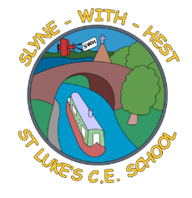
Slyne-with-Hest St Luke’s C.E. Primary School
Year 5 Curriculum Information
Autumn Term 1 2025
English  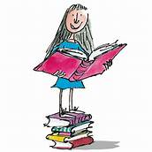 | This half term in English we will be basing our English work on our Space topic. We will start by reading a short story about an Alien Landing and use this as a basis for our own story writing. We will then follow this with some poetry using the moon as our inspiration. Our class novel this half term will be ‘Cosmic’ by Frank Cottrel-Boyce. We will focus on word classes during our SPAG sessions and develop our reading skills through focused comprehension sessions.
Maths  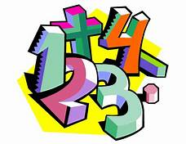 | This half term in maths we will be developing our mental and written strategies for addition and subtraction including problem solving. We will be recapping our understanding of place value including looking at place value involving decimals. We will be looking at problems involving angles and perimeter. Our weekly arithmetic work will involve problems on all 4 rules of arithmetic, fractions, percentage and decimals.
Science   | Science will be linked to our topic of Space. We will consider the movement and position of our planet Earth in relation to the sun, moon and other planets in our solar system. We will think about how and why night and day happen and link this to a study of our shadows, as well as observing the moon and its different phases over the course of the half term.
Theme (History / Geography/ Art and DT / Music)  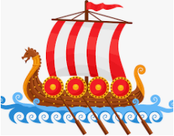 | Our topic this half term is space. Our focus during Theme will be the history of space travel with a particular focus on the space race. We will look at the first people to go into space and how space travel has developed and changed over time. In Art, we will be exploring how we can create typography through drawing and design, and use our skills to create personal and highly visual maps. Our Music work will also link to the class ‘Space’ theme – we will be listening to extracts from ‘The planet suite’ and using themes and motifs for our own compositions. We will learn some ‘space’ songs – working hard to reflect pitch, dynamics and duration accurately.
R.E. | We will begin the year by looking at the Bible. We will consider and compare some of the different versions of the holy book which can be found, as well as reflecting on why Christians read the Bible. The children will look in more depth at how the Bible content is arranged into books and learn more about these, as well as thinking about some of the key messages we can take from the Bible overall to help us in our daily lives.
Home School Partnership  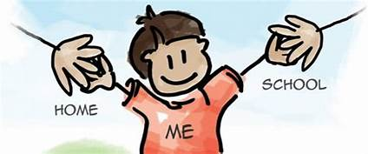 | We would like you to help your child at home with the following activities:  - Reading at least three times a week – more if you can!  - Completing weekly English and Maths homework – English will be set on a Monday and Maths on a Friday.  - Supporting with practicing spellings on Spelling Shed. Our spelling test will be on Monday.  - Supporting with completing tournaments and playing games on TT Rockstars
Reminders | This half term PE will be on a Tuesday and Friday. Children should come to school in their PE kit on this day so they don’t need to get changed.

