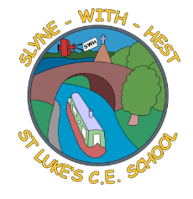
Slyne-with-Hest St Luke’s C.E. Primary School
EYFS Curriculum Information
Autumn Term 1 2025
English  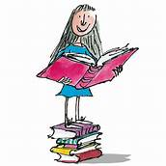 | To start the term we will encourage good speaking behaviours, such as waiting your turn to speak and answering when someone is speaking to you.  We will have many small group opportunities to develop these.  After careful assessments of where the children are, we will begin phonics lessons, where the children will start on their journeys to learn to read and write. When they are judged to be ready, some of the children will bring home reading books each night.  We will start to learn a poem each week.
Maths  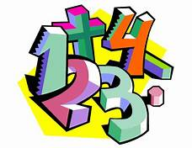 | In Maths we use the White Rose scheme of work.  We will do lots of counting, including counting songs and rhymes. We will spend time sorting and matching as well as comparing amounts and exploring making patterns. We will compare sizes and amounts and develop the vocabulary to go with these.
Topics   | To begin the term we will explore nursery rhymes. We will spend time learning plenty as well as using them as a starting point for our weekly topics; exploring spiders, shoes, fish and stars in particular. Towards the end of the half term we will spend time looking at the world around us as we think about harvest and then autumn time.
R.E. | Our RE work is based on the Blackburn Diocesan scheme.  Our first topic will be ‘I am Special’, followed by work on Harvest.
Home School Partnership   | We would like you to help your child at home with the following activities:  - Helping them with early phonics (I will explain this at the early parent – teacher meetings).  - Making time for meaningful conversations with your child, where they are expected to join in properly.
Reminders | This half term PE will be on Wednesdays and Fridays.  Children should come to school in their PE kit on this day so they don’t need to get changed.

