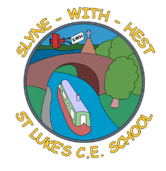
Slyne-with-Hest St Luke’s C.E. Primary School
Year 1 Curriculum Information
Summer Term 1 2025
English   | This half term will be spent looking at the Katie Morag stories, linked to our topic work. We will continue to work on our sentence structure and handwriting. We will also be looking at writing recounts of ‘Katie Morag Delivers the Mail’ inline with our class assembly.  In Phonics, we will be revising Phase 5 sounds in preparation for the Phonics screening later this half term.
Maths | We will start by continuing our work on place value, before moving onto addition and subtraction problems. We will then move onto division, including halving odd numbers. Finally, we will look at geometry, including positional language, quarter turns and problem-solving using time.
Science   | This half term we will be learning about Plants. We will be looking different types of plants and the children are expected to be able to name a variety of garden and wild plants/flowers. This is a great excuse to get them out in nature and explore what they can see around them. We will also be looking at the different parts of a plant and different types of trees.
Theme (History / Geography/ Art and DT)  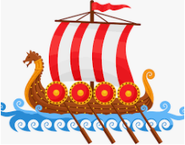 | The main class theme this half term is ‘An Island Home’ and it is a geography-based topic. We will be learning about the physical and human features of our locality and that of the Scottish Ilse of Coll. We will be thinking about buildings, jobs and transport links and will base it around the Katie Morag stories to link in with the English work.
  R. E. | This half term our unit of work (based on the Blackburn Diocesan scheme) is  Baptism. If your child has been baptised it would be lovely if you could share some photos with them (and us if possible!) and look at any special objects you have Eg candles, cards, gifts, clothes etc. We will hopefully be spending one of our lessons in church re-enacting a baptism service.
Home School Partnership   | We would like you to help your child at home with the following activities:  - Reading at least three times in a week more if you can!  - Supporting with learning spellings / high frequency words  - Look at and name any plants you have growing in your garden.  - Discuss any special memories you have from family baptisms.
Reminders   | This half term PE will be on a Monday and Thursday.  Children should come to school in their PE kit on this day so they don’t need to get changed.

