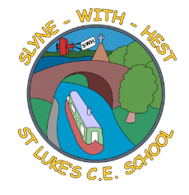
Slyne-with-Hest St Luke’s C.E. Primary School
Year 1 Curriculum Information
Spring Term 2024
English  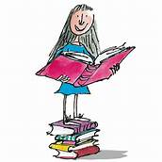 | This half term will be spent looking at story writing, linked to our topic work. We will continue to work on our sentence structure and handwriting. We will also be looking at writing short narratives, including interesting descriptions and using the correct structure of a story.  In Phonics, we will be revising Phase 5 sounds in preparation for the Phonics screening later this half term.
Maths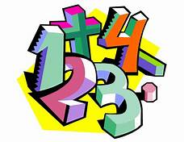 | We will start by continuing our work on place value to 50 and beyond, reading, recognizing, partitioning and word problems. We will also be continuing to practice addition and subtraction within 50. Any extra work you can do at home to reinforce the learning would be great. Later in the term, we will explore multiplication (sets of) and division (sharing). We will then move onto measures including length, mass, volume and capacity.
Science   | This term in Science we are looking at Everyday Materials. We will be looking closely at objects and the materials are made from as well as testing materials for their properties. We will also be continuing to look at seasonal changes.
Theme (History / Geography/ Art and DT)  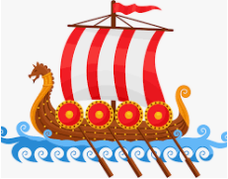 | The main class theme this half term is Toys Past and Present and it is a history-based topic. We will be learning about toys from the past through to modern times including what the toys of old were made out of, how they were used and how they are different from our own. Our Art work will be linked to this through making paper toys.  In DT we will be exploring how to make moving toys involving the use of wheels, axles and axle holders.
  R. E. | In RE we are thinking about the Easter Story. We will be looking at signs of new life around the school grounds and thinking about a butterfly life cycle. We will link this to Jesus dying and being raised again to new life.  During this term, we will also be looking as specific parts of the Easter Story and thinking about what they mean to use.
Home School Partnership  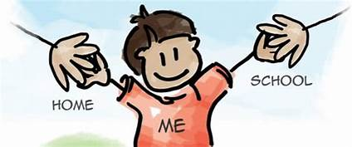 | We would like you to help your child at home with the following activities:  - Reading at least three times in a week more if you can!  - Supporting with learning spellings / high frequency words  - Look at and name any plants you have growing in your garden.  - Discuss any special memories you have from family baptisms.
Reminders   | This half term PE will be on a Monday and Thursday.  Children should come to school in their PE kit on this day so they don’t need to get changed.

