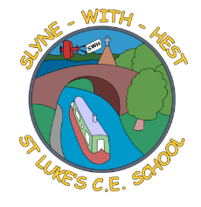
Slyne-with-Hest St Luke’s C.E. Primary School
Year 1 Curriculum Information
Spring Term 2025
English   | This half term will be spent looking at story writing, linked to our topic work, and the story “Lost and Found.” We will continue to work on our sentence structure and handwriting. We will also be looking at writing short narratives, including character and setting descriptions and using the correct structure of a story.  In Phonics, we will be revising Phase 5 sounds in preparation for the Phonics screening later this year.
Maths | We will start by continuing our work on place value. We will also be continuing to practice addition and subtraction. Any extra work you can do at home to reinforce the learning would be great. Later in the term, we will explore multiplication (sets of) and division (sharing). We will then move onto measuring mass. Finally, we will be learning to recognise and count money.
Science   | This term in Science we are continuing to look at winter. We will be looking at how animals can adapt to the cold including migration, hibernation and adaptation. We will also be looking into weather forecasting before writing and presenting our own.
Theme (History / Geography/ Art and DT)   | The main class theme this half term is Polar Lands. With a particular focus on what life is like in the North and South poles. We will consider the wildlife, climate and the effect that climate change is having on these regions. We will complete the topic by comparing life in the Polar Lands to life in Slyne, referring back to our work earlier in the year.
  R. E. | In RE we are thinking about what made Jesus special. We will consider miracle stories, discussing what the miracles taught us, and how they show Jesus was the Son of God. We will also consider why the disciples wanted to be Jesus’ special friend.
Home School Partnership   | We would like you to help your child at home with the following activities:  - Reading at least three times in a week more if you can!  - Supporting with learning spellings / high frequency words  - Discussing the changing weather
Reminders   | This half term PE will be on a Monday and Thursday.  Children should come to school in their PE kit on this day so they don’t need to get changed.

