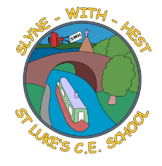
Slyne-with-Hest St Luke’s C.E. Primary School
Year 1 Curriculum Information
Autumn Term 2 2024
English  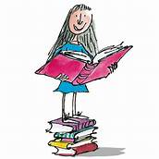 | This half term we will continue to develop our reading and writing focus. We will start with a unit on poetry, linked to Fireworks. After watching some fireworks it would be helpful if you discussed with your child the colours/shapes they could see and the sounds they heard. We will then move onto looking at a story with a repetitive pattern, “Zog.”  Writing for the purpose of Christmas will also make up a great proportion of our writing this half term.
Maths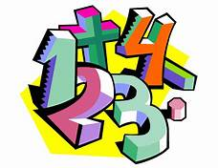 | We will continue our work on addition and subtraction, looking at using a number line to subtract and creating addition and subtraction fact families. We will then look at 2D and 3D shapes before moving back to number and place value of numbers up to 20.
Science   | We are continuing with our work on Humans as animals this half term, including work on the 5 senses. We will also be continuing our work on autumn focusing on what animals do to prepare for winter and the signs that it is autumn in the daylight and weather.
Theme (History / Geography/ Art and DT)  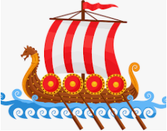 | The Topic for this half term is Celebrations. We will start off by going back in time to Bonfire Night and find out why Guy Fawkes really didn't like King James 1! We will then think about other important dates such as Remembrance Sunday and why the poppy is so important. Diwali, the Hindu festival, is always a popular celebration to learn about and it will involve making our own diya lamps. Of course, we finish by looking at the traditions surrounding our Christmas Festival.  Lots to keep us busy and lots to celebrate.
  R. E. | We are first going to complete our work on Creation by looking at creation stories from other world faiths. We will make comparisons between the Hindu creation story and the Christian one we have become very familiar with. Then we will move onto our Christmas RE topic looking at why we give and receive gifts and retelling the Nativity story.
Home School Partnership   | We would like you to help your child at home with the following activities:  - Reading at least three times in a week more if you can!  - Playing simple games like snakes and ladders, card games etc  - Encourage your child to do small pieces of writing; postcards, shopping lists, labels etc to practice using their phonics to help write.
Reminders   | PE will be on a Monday and Thursday.  Children should come to school in their PE kit on this day so they don’t need to get changed. Please remember to remove any earrings before coming to school on those days.

