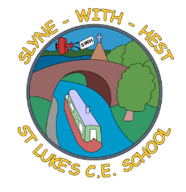
Slyne-with-Hest St Luke’s C.E. Primary School
Year 1 Curriculum Information
Autumn Term 1 2024
English  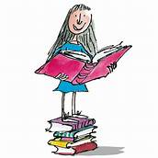 | The beginning of Year 1 is all about developing our skills to become readers and writers. We will be picking up where the children left off in their Reception phonics work during our daily phonics session and continuing to encourage them to practice their reading as often as possible. We will start the year looking at Traditional tales, focusing on The Three Little Pigs. We will be doing lots of writing based around the story.
Maths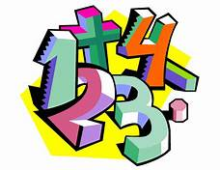 | We will be starting our Maths work looking at numbers up to 10 during our work on place value. We will be ordering, comparing and sorting numbers. We will also look at one more and one less. We will be answering questions such as Which number is the biggest / greatest? Can you prove this using equipment? Can you order the numbers smallest to greatest? How have the numbers been ordered? How do you know?  We will then move onto addition and subtraction using equipment and pictures.
Science   | This half term we will be learning about humans as animals. We will be naming and labelling body parts, comparing our bodies to each other and other animals and thinking about what parts of the body we use for our 5 senses. We will also be starting our work on seasonal change. We focus on this at different points throughout the year. We will begin by looking at the changes we see around us as we move into autumn.
Theme (History / Geography/ Art and DT)  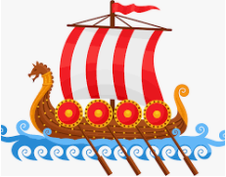 | The main class theme this half term is ‘Our Place’ and so we will be focusing on developing our geography skills.  We will be looking at where we live and what is special about Slyne village. We will investigate and have a go at drawing maps.
  R. E. | This half term our unit of work (based on the Blackburn Diocesan scheme) is  God and Creation. We will look at the Creation story and take time to look at God’s creation. We will write prayers of thanks and think about what we can do to look after our world.
Home School Partnership  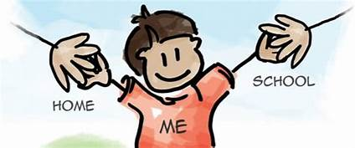 | We would like you to help your child at home with the following activities:  - Reading at least three times in a week more if you can!  - Playing simple games like snakes and ladders, card games etc  - Looking at the changes we see around us as we move from summer to autumn. What is happening to the trees/weather/animals? More activities linked to this will follow closer to half term.
Reminders   | PE will be on a Monday and Thursday.  Children should come to school in their PE kit on this day so they don’t need to get changed. Please remember to remove any earrings before coming to school on those days.

