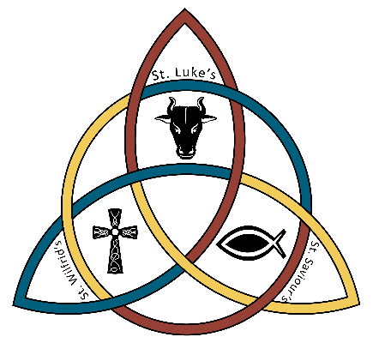
The United Benefice of Slyne with Hest and Halton with Aughton

The Vicarage
2 Summerfield Drive
Slyne with Hest
LA2 6AQ
01524 822128
revsusan.seed@btinternet.com

Confirmation

Dear Parent,
I invite you to consider whether your child in year six might like to be confirmed in the spring term. The confirmation service has been arranged for Sunday 9th March 2025 10.30am at Holy Trinity with Bishop Jill Duff. Preparation sessions for the young people will take place on Wednesdays after school in the church, starting Wednesday 22nd January.
What is Confirmation?
Confirmation enables young people to make their own commitment to the Christian faith, “with your own mouth and from your own heart” (to quote from the service). Within the service the Bishop will pray for the gift of the Holy Spirit, laying hands on each of the candidates.
Many of our young people were baptised as babies, with the decision at that time being made on their behalf by their parents and godparents. Through confirmation our young people can ‘confirm’ their own faith now that they are old enough to consider it for themselves.
What are the Preparation Sessions for?
Through the weekly sessions your child will be given the opportunity to explore some of the big questions in a way that is relaxed and fun alongside others their age. The preparation dates and various topics are shown on the reverse. If your child would like to be confirmed, but the timing of the Wednesday preparation sessions is going to be a problem, then get in touch with me and we’ll see what alternatives we can come up with.
Whose decision is this?
It is important that the decision to get confirmed is made by the young person themselves. Talk to your child about whether this is something they would like to do. Any who have not already been baptised can join in; they would be baptised as well as confirmed by the Bishop within the same service.
We can also confirm any adults who now wish to affirm their Christian faith in their adult years – it is never too late! We sometimes have mums and dads confirmed alongside their children.

How do I respond?

To sign up please COMPLETE THE RESPONSE FORM and return it to me in church or by post to the Vicarage or email to revsusan.seed@btinternet.com
With my best wishes,
Revd Susan
CONFIRMATION PREPARATION
Wednesdays 4.00 – 5.00pm
at Holy Trinity Church Bolton-Le Sands
Session 1 Wednesday 22nd January
INTRODUCTORY SESSION

Session 2 Wednesday 29th January
OH MY GOD!
How easy is it to believe in God?
What are some reasons why we can have faith?

Session 3 Wednesday 5th February
JESUS WHO?
Exploring the identity of Jesus.

Session 4 Wednesday 12th February
THE HOLY SPIRIT
Understanding the person and work of the Holy Spirit.

HALF TERM BREAK

Session 5 Wednesday 26th February
PRAYER & THE BIBLE
How can the prayer and the bible help us in our Christian life?

Session 6 Wednesday 5th March
IT’S MY DECISION & REHEARSAL

