Reception Yearly Curriculum Overview
Autumn Term | Nursery Rhymes  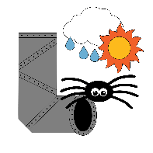 | 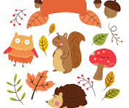  Autumn & Harvest |   Bonfire Night |  |   People Who Help Us |  | 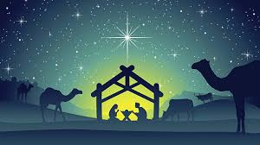  Christmas
Spring Term |   Weather & Seasons |   Chinese New Year |   Health Week |  |   In the Past |  |   Spring, New Life & Easter
Summer Term | Our 5 Senses   |  |  | Wellbeing Week   |  | 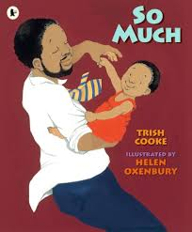  Let’s Explore Books and Stories
Work on the 4 Patron Saints will be slotted into the correct places in the Autumn, Spring and Summer terms.

